**University of Michigan – Dearborn**

**CIS 150 – Computer Science 1**

**Lab# 8**

**Professor Bacha**

Demetrius Johnson

[meech@umich.edu](mailto:meech@umich.edu)

March 11, 2020

**Table Content**

Contents

Question 1 3

Test Cases 3

Source Code – see LAB8Q1.cpp 3

Screenshots 4

Question 2 6

Test Cases 6

Source Code – see LAB8Q2.cpp 6

Screenshots 6

# Question 1

## Test Cases

|  |  |  |  |  |  |
| --- | --- | --- | --- | --- | --- |
| Test # | Valid / Invalid Data | Description of test | Input Value | Actual Output | Test Pass / Fail |
| 1 | valid | Test to see if all functions work correctly when passing in array | Original question array | See screenshot | pass |
| 2 | valid | NOTE: Only the first test displays original array calculated from the question; all other tests I simply manipulated array values however it is not shown in the original C-OUT from my menu function | Manipulated values of the same length array from original question | See screenshot | pass |
| 3 | valid | . NOTE: Only the first test displays original array calculated from the question; all other tests I simply manipulated array values however it is not shown in the original C-OUT from my menu function | Manipulated values of the same length array from original question | See screenshot | pass |
| 4 | valid | . NOTE: Only the first test displays original array calculated from the question; all other tests I simply manipulated array values however it is not shown in the original C-OUT from my menu function | Manipulated values of the same length array from original question | See screenshot | pass |

## Source Code – see LAB8Q1.cpp

## Screenshots

TEST 1

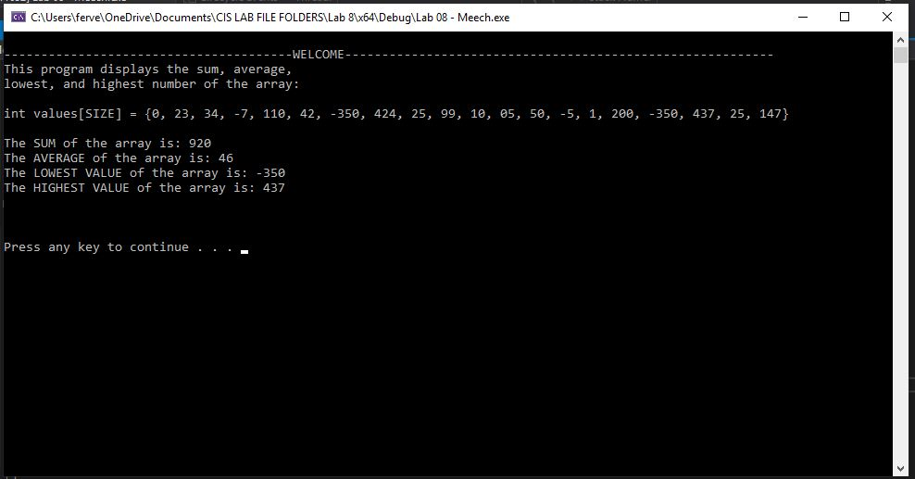

TEST 2

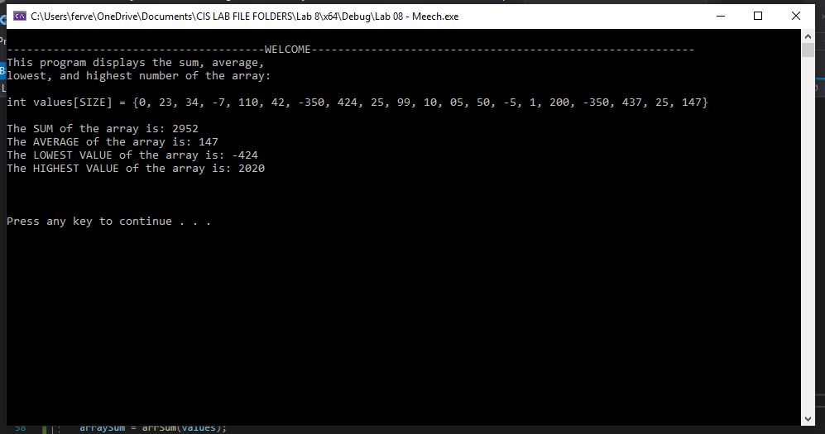

TEST 3

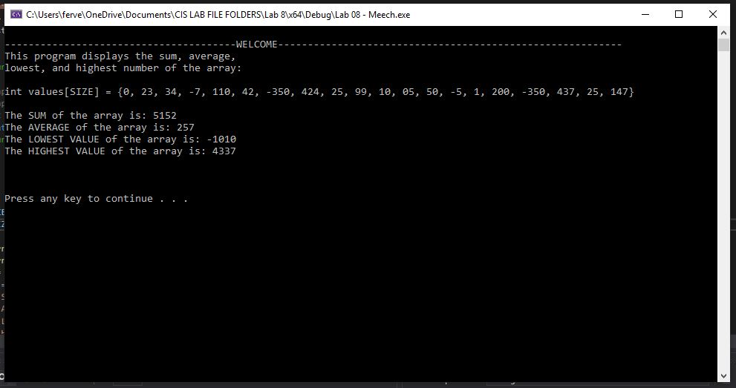

TEST 4

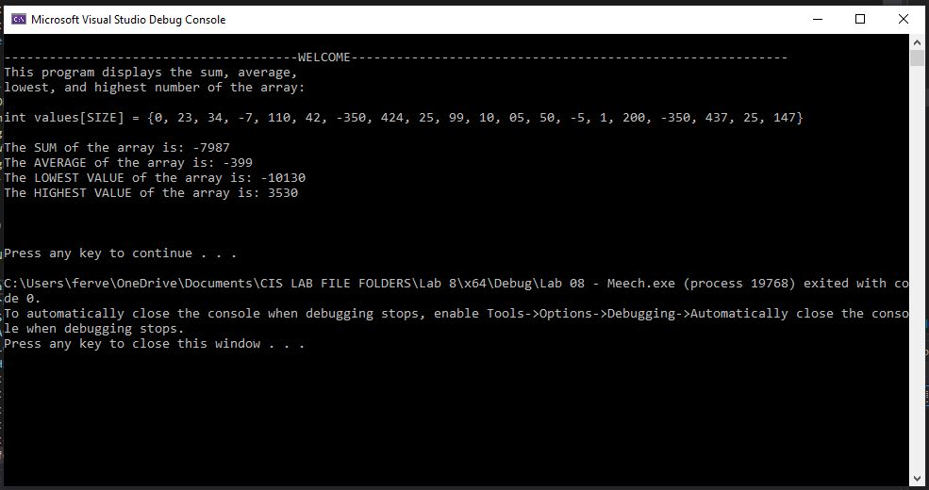

# Question 2

## Test Cases

|  |  |  |  |  |  |
| --- | --- | --- | --- | --- | --- |
| Test # | Valid / Invalid Data | Description of test | Input Value | Actual Output | Test Pass / Fail |
| 1 | valid | Test to see if a value is in the array. | userVal = -1 | See screenshot | pass |
| 2 | valid | Test to see if a value is in the array. | userVal = 50 | See screenshot | pass |
| 3 | valid | Test to see if a value is in the array. | userVal = 27 | See screenshot | pass |
| 4 | valid | Test to see if a value is in the array. | userVal = 0 | See screenshot | pass |

## Source Code – see LAB8Q2.cpp

## Screenshots

TEST 1

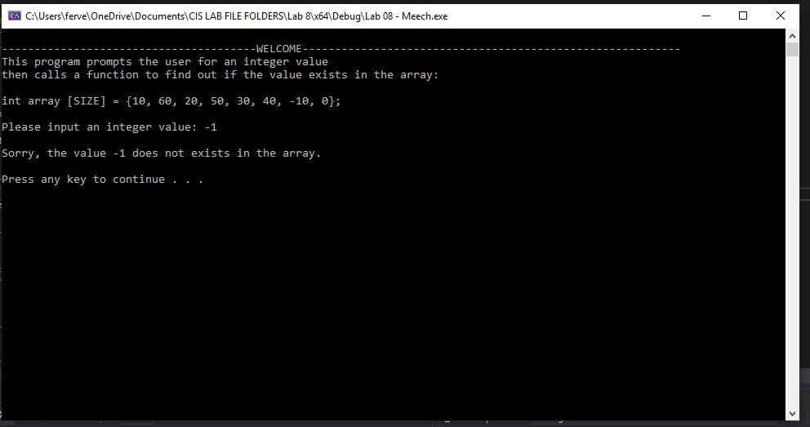

TEST 2

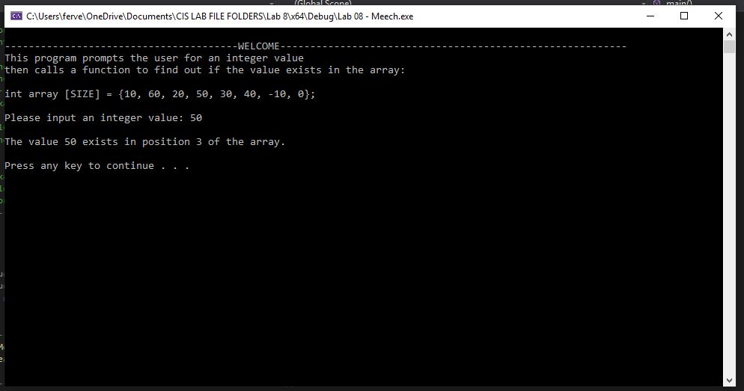

TEST 3

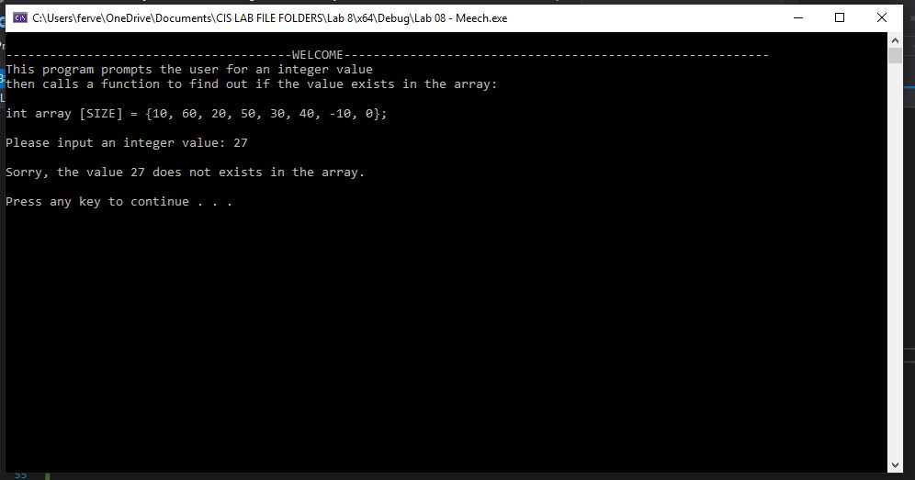

TEST 4

